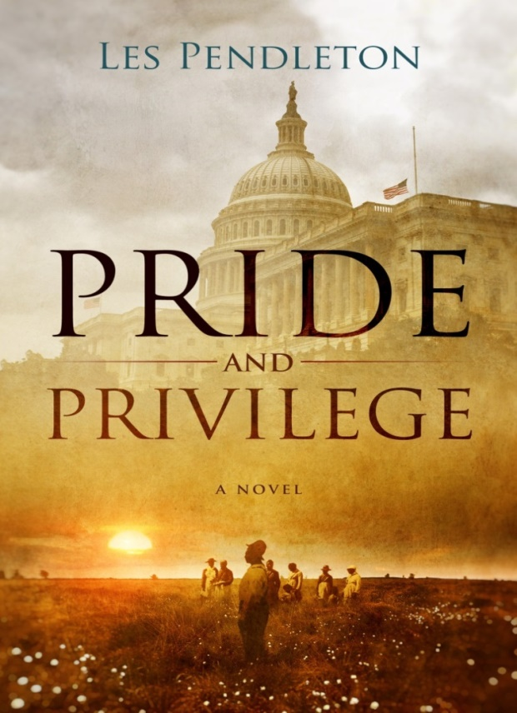
Though beautiful and romantic, the old South had a very dark underside. Dwight Morton, heir to a powerful dynasty in rural South Carolina, became one of the most beloved Senators of his time. A pillar of integrity and devoted to the less privileged, his deathbed confession to a horrendous crime that brought his entire life and legacy into question. His reputation as a philanthropist and humanitarian was unmatched. Dwight’s last hours were spent relating his story to Oscar Phipps, a longtime friend and editor of a small South Carolina newspaper. While Oscar is spending all of this time in and out of Dwight’s hospital room, he encounters two young brothers whose mother is also a patient there. He sees the great similarities in their plight and Dwight’s incredible tale from a fifty years earlier. He will be forced to make the same decision the Senator faced, should he get involved or just let life play out without his intervention. One choice and he’s enmeshed far more than he has the time and energy for, and the other he’s away clean, except for his conscience. This story covers over half a century in the life of one extraordinary man and those who made him what he was to become. This novel will place you there as the events unfold.

